Site info:

**Earls Lincoln Park, New City, Chicago, IL**

Hostname: earls-lincolnpark-tgdvbvncjn.dynamic-m.com

Pre-shared Key: FwH63Cbg2XRhNOFeEyUIdFsY2592E0Uu

Jace Control: 10.0.63.195

Jace Surface: 10.0.63.196

**Earls Mall at Millenia, Orlando, FL**

Hostname: earls-mallatmillenia-rjrdwbzpjn.dynamic-m.com

Pre-shared Key: FwH63Cbg2XRhNOFeEyUIdFsY2592E0Uu

Jace Control: 10.0.64.197

Jace Surface: 10.0.64.198

**Earls Legacy Park West, Plano, TX**

Hostname: earls-legacywest-qmnpqnmqjn.dynamic-m.com

Pre-shared Key: FwH63Cbg2XRhNOFeEyUIdFsY2592E0Uu

Jace Control: 10.0.65.197

Jace Surface: 10.0.65.198

SC: 10.0.65.199

**Earls Prudential**

Hostname: earls-prudential-hjnmnrrcjn.dynamic-m.com

Pre-shared Key: FwH63Cbg2XRhNOFeEyUIdFsY2592E0Uu

Jace Control: 10.0.66.197

Jace Surface: 10.0.66.198

SC: 10.0.66.199

VPN configuration info:

Click ‘start’, enter ‘VPN’, pick ‘Change virtual private networks (VPN)’

Pick ‘Add a VPN connection’

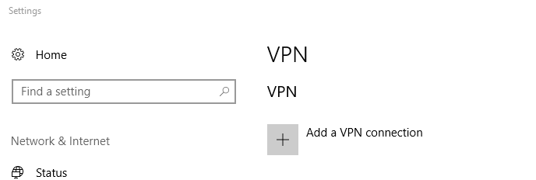

In Settings:

VPN Provider = Windows (built-in)

Connection name = earls Lincoln Park Chicago IL

Server name = earls-lincolnpark-tgdvbvncjn.dynamic-m.com

VPN type = L2TP/IPsec with pre-shared key

Pre-shared key = FwH63Cbg2XRhNOFeEyUIdFsY2592E0Uu

Type of sign-in info = User name and password

User name (optional) = crider@nomadgroup.com

Password (optional) = dg326jR8

Remember my sign-in info = checked

Open Network Connections , right click on the newly created VPN connection and pick properties

Under Data encryption pick Require encryption (disconnect if server declines)

Under Authentication pick Allow these protocols

Check Unencrypted password (PAP) and uncheck all others

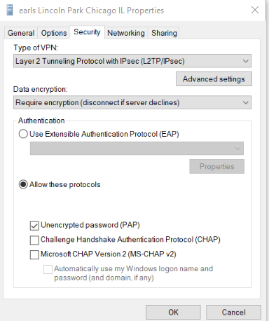

Pick Advanced settings

Key = same key as above

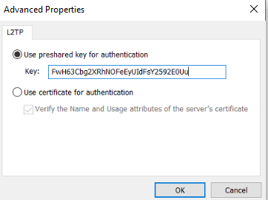

Accept all the ‘OK’s and you should be able to connect

You should now be able to launch ProBuilder and connect